Игры для детей на развитие чувства музыкального темпа

[](https://ok.ru/dk?cmd=PopLayerPhoto&st.layer.cmd=PopLayerPhotoOuter&st.layer.type=GROUP&st.layer.revNav=off&st.layer.limitedUi=false&st.layer.closeLayers=off&st.layer.sphotoIds=873629565141%3B873629570005%3B873629569749%3B873629569493&st.layer.showNav=on&st.layer.photoAlbumId=52327617003733&st.layer.epm=off&st.layer.photoId=873629565141&st.layer.opl=off&st.layer.navStartPhotoId=873629565141&st.layer.sbd=off&st.cmd=altGroupForum&st.groupId=52327565361365&st._aid=GroupTopicLayer_openPhotoLayer)

[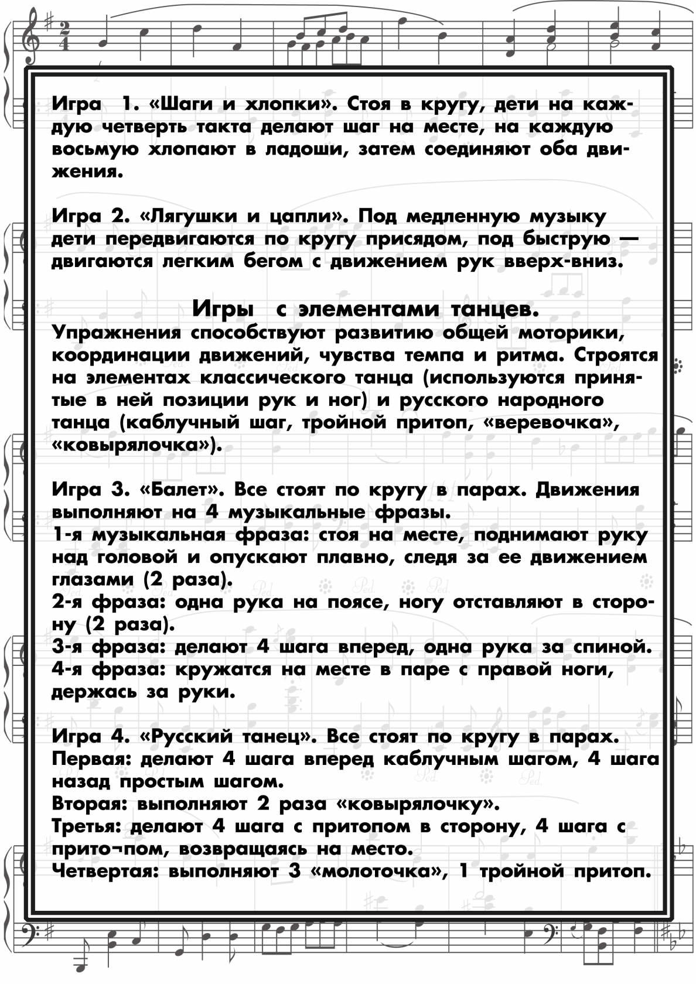](https://ok.ru/dk?cmd=PopLayerPhoto&st.layer.cmd=PopLayerPhotoOuter&st.layer.type=GROUP&st.layer.revNav=off&st.layer.limitedUi=false&st.layer.closeLayers=off&st.layer.sphotoIds=873629565141%3B873629570005%3B873629569749%3B873629569493&st.layer.showNav=on&st.layer.photoAlbumId=52327617003733&st.layer.epm=off&st.layer.photoId=873629570005&st.layer.opl=off&st.layer.navStartPhotoId=873629570005&st.layer.sbd=off&st.cmd=altGroupForum&st.groupId=52327565361365&st._aid=GroupTopicLayer_openPhotoLayer)

[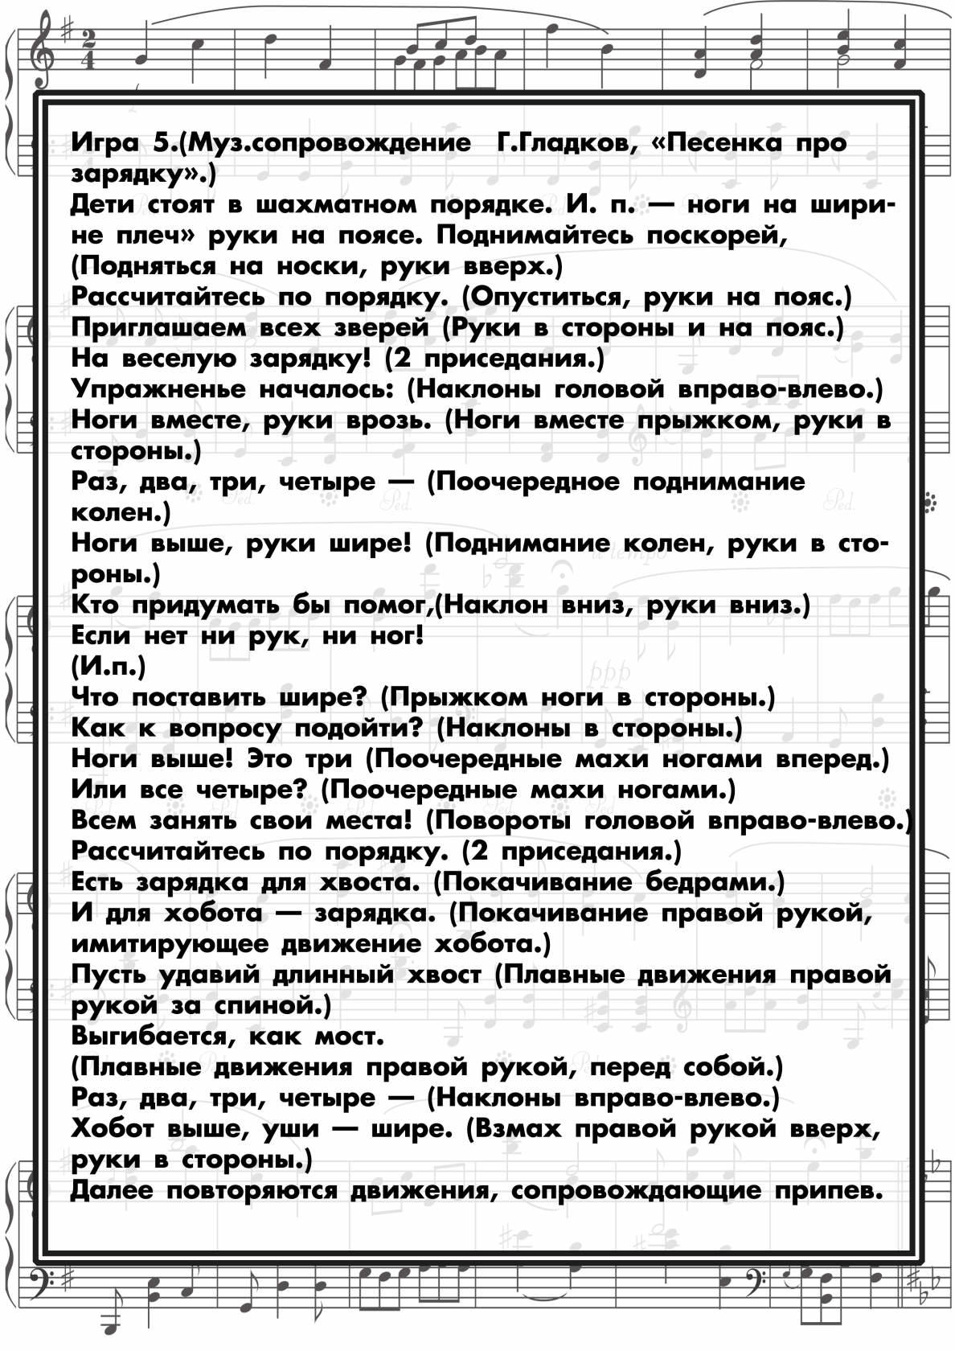](https://ok.ru/dk?cmd=PopLayerPhoto&st.layer.cmd=PopLayerPhotoOuter&st.layer.type=GROUP&st.layer.revNav=off&st.layer.limitedUi=false&st.layer.closeLayers=off&st.layer.sphotoIds=873629565141%3B873629570005%3B873629569749%3B873629569493&st.layer.showNav=on&st.layer.photoAlbumId=52327617003733&st.layer.epm=off&st.layer.photoId=873629569749&st.layer.opl=off&st.layer.navStartPhotoId=873629569749&st.layer.sbd=off&st.cmd=altGroupForum&st.groupId=52327565361365&st._aid=GroupTopicLayer_openPhotoLayer)

[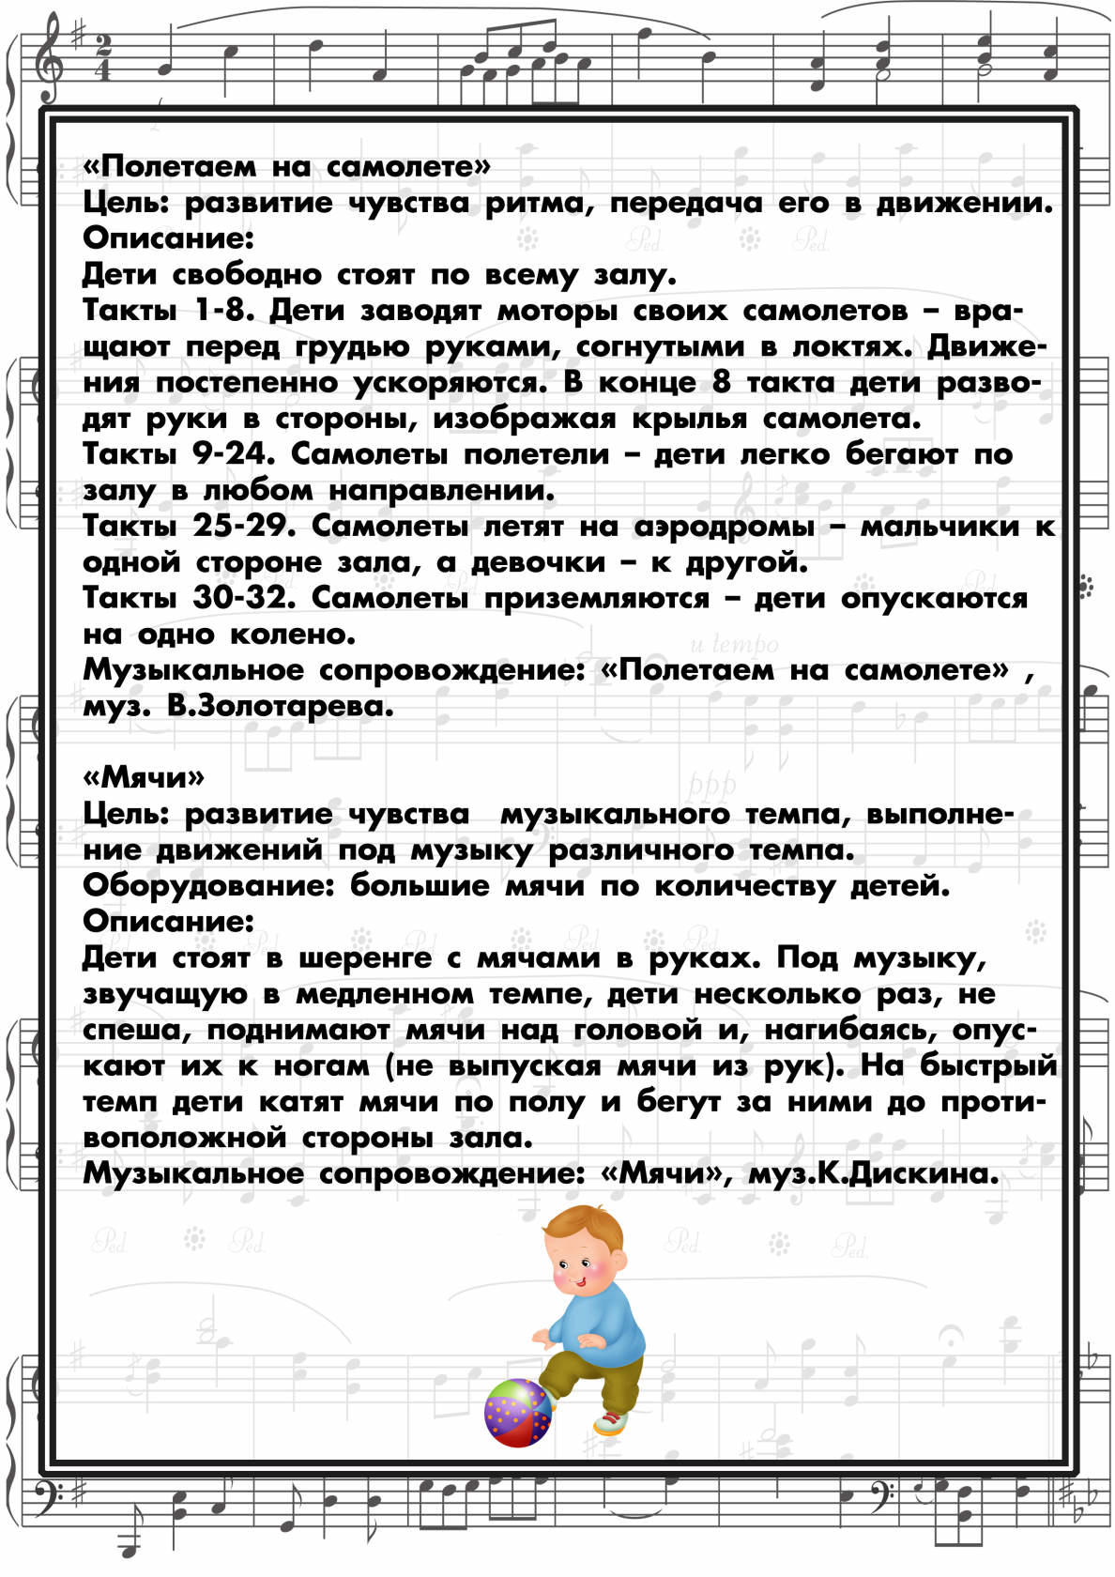](https://ok.ru/dk?cmd=PopLayerPhoto&st.layer.cmd=PopLayerPhotoOuter&st.layer.type=GROUP&st.layer.revNav=off&st.layer.limitedUi=false&st.layer.closeLayers=off&st.layer.sphotoIds=873629565141%3B873629570005%3B873629569749%3B873629569493&st.layer.showNav=on&st.layer.photoAlbumId=52327617003733&st.layer.epm=off&st.layer.photoId=873629569493&st.layer.opl=off&st.layer.navStartPhotoId=873629569493&st.layer.sbd=off&st.cmd=altGroupForum&st.groupId=52327565361365&st._aid=GroupTopicLayer_openPhotoLayer)