**Картотека народных подвижных игр**

[](https://ok.ru/dk?cmd=PopLayerPhoto&st.layer.cmd=PopLayerPhotoOuter&st.layer.type=GROUP&st.layer.revNav=off&st.layer.limitedUi=false&st.layer.closeLayers=off&st.layer.sphotoIds=873643025621;873643025365;873643025109;873643024853;873643024597;873643024341;873643024085;873643023829;873643023573;873643023317&st.layer.showNav=on&st.layer.photoAlbumId=52327617003733&st.layer.epm=off&st.layer.photoId=873643025621&st.layer.opl=off&st.layer.navStartPhotoId=873643025621&st.layer.sbd=off&st.cmd=userMain&st._aid=GroupTopicLayer_openPhotoLayer)

[](https://ok.ru/dk?cmd=PopLayerPhoto&st.layer.cmd=PopLayerPhotoOuter&st.layer.type=GROUP&st.layer.revNav=off&st.layer.limitedUi=false&st.layer.closeLayers=off&st.layer.sphotoIds=873643025621;873643025365;873643025109;873643024853;873643024597;873643024341;873643024085;873643023829;873643023573;873643023317&st.layer.showNav=on&st.layer.photoAlbumId=52327617003733&st.layer.epm=off&st.layer.photoId=873643025365&st.layer.opl=off&st.layer.navStartPhotoId=873643025365&st.layer.sbd=off&st.cmd=userMain&st._aid=GroupTopicLayer_openPhotoLayer)

[](https://ok.ru/dk?cmd=PopLayerPhoto&st.layer.cmd=PopLayerPhotoOuter&st.layer.type=GROUP&st.layer.revNav=off&st.layer.limitedUi=false&st.layer.closeLayers=off&st.layer.sphotoIds=873643025621;873643025365;873643025109;873643024853;873643024597;873643024341;873643024085;873643023829;873643023573;873643023317&st.layer.showNav=on&st.layer.photoAlbumId=52327617003733&st.layer.epm=off&st.layer.photoId=873643025109&st.layer.opl=off&st.layer.navStartPhotoId=873643025109&st.layer.sbd=off&st.cmd=userMain&st._aid=GroupTopicLayer_openPhotoLayer)

[](https://ok.ru/dk?cmd=PopLayerPhoto&st.layer.cmd=PopLayerPhotoOuter&st.layer.type=GROUP&st.layer.revNav=off&st.layer.limitedUi=false&st.layer.closeLayers=off&st.layer.sphotoIds=873643025621;873643025365;873643025109;873643024853;873643024597;873643024341;873643024085;873643023829;873643023573;873643023317&st.layer.showNav=on&st.layer.photoAlbumId=52327617003733&st.layer.epm=off&st.layer.photoId=873643024853&st.layer.opl=off&st.layer.navStartPhotoId=873643024853&st.layer.sbd=off&st.cmd=userMain&st._aid=GroupTopicLayer_openPhotoLayer)

[](https://ok.ru/dk?cmd=PopLayerPhoto&st.layer.cmd=PopLayerPhotoOuter&st.layer.type=GROUP&st.layer.revNav=off&st.layer.limitedUi=false&st.layer.closeLayers=off&st.layer.sphotoIds=873643025621;873643025365;873643025109;873643024853;873643024597;873643024341;873643024085;873643023829;873643023573;873643023317&st.layer.showNav=on&st.layer.photoAlbumId=52327617003733&st.layer.epm=off&st.layer.photoId=873643024597&st.layer.opl=off&st.layer.navStartPhotoId=873643024597&st.layer.sbd=off&st.cmd=userMain&st._aid=GroupTopicLayer_openPhotoLayer)

[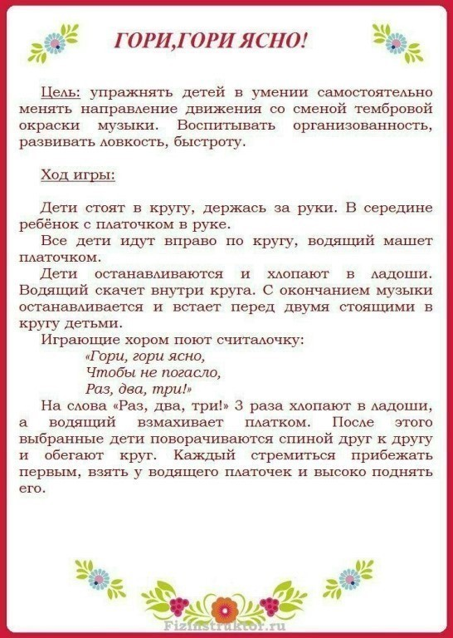](https://ok.ru/dk?cmd=PopLayerPhoto&st.layer.cmd=PopLayerPhotoOuter&st.layer.type=GROUP&st.layer.revNav=off&st.layer.limitedUi=false&st.layer.closeLayers=off&st.layer.sphotoIds=873643025621;873643025365;873643025109;873643024853;873643024597;873643024341;873643024085;873643023829;873643023573;873643023317&st.layer.showNav=on&st.layer.photoAlbumId=52327617003733&st.layer.epm=off&st.layer.photoId=873643024341&st.layer.opl=off&st.layer.navStartPhotoId=873643024341&st.layer.sbd=off&st.cmd=userMain&st._aid=GroupTopicLayer_openPhotoLayer)

[](https://ok.ru/dk?cmd=PopLayerPhoto&st.layer.cmd=PopLayerPhotoOuter&st.layer.type=GROUP&st.layer.revNav=off&st.layer.limitedUi=false&st.layer.closeLayers=off&st.layer.sphotoIds=873643025621;873643025365;873643025109;873643024853;873643024597;873643024341;873643024085;873643023829;873643023573;873643023317&st.layer.showNav=on&st.layer.photoAlbumId=52327617003733&st.layer.epm=off&st.layer.photoId=873643024085&st.layer.opl=off&st.layer.navStartPhotoId=873643024085&st.layer.sbd=off&st.cmd=userMain&st._aid=GroupTopicLayer_openPhotoLayer)

[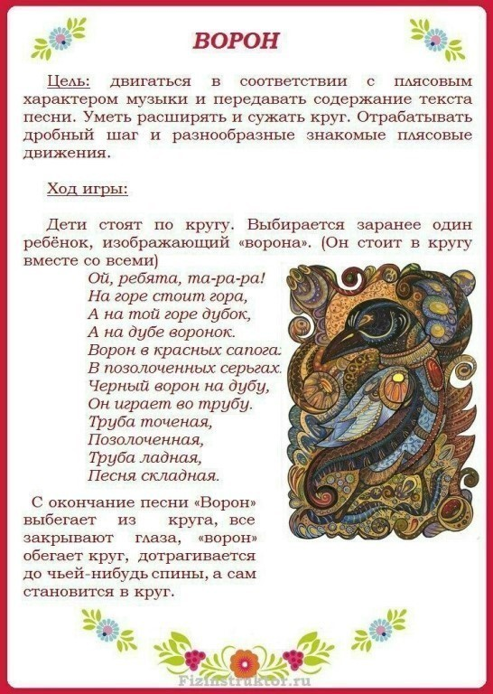](https://ok.ru/dk?cmd=PopLayerPhoto&st.layer.cmd=PopLayerPhotoOuter&st.layer.type=GROUP&st.layer.revNav=off&st.layer.limitedUi=false&st.layer.closeLayers=off&st.layer.sphotoIds=873643025621;873643025365;873643025109;873643024853;873643024597;873643024341;873643024085;873643023829;873643023573;873643023317&st.layer.showNav=on&st.layer.photoAlbumId=52327617003733&st.layer.epm=off&st.layer.photoId=873643023829&st.layer.opl=off&st.layer.navStartPhotoId=873643023829&st.layer.sbd=off&st.cmd=userMain&st._aid=GroupTopicLayer_openPhotoLayer)

[](https://ok.ru/dk?cmd=PopLayerPhoto&st.layer.cmd=PopLayerPhotoOuter&st.layer.type=GROUP&st.layer.revNav=off&st.layer.limitedUi=false&st.layer.closeLayers=off&st.layer.sphotoIds=873643025621;873643025365;873643025109;873643024853;873643024597;873643024341;873643024085;873643023829;873643023573;873643023317&st.layer.showNav=on&st.layer.photoAlbumId=52327617003733&st.layer.epm=off&st.layer.photoId=873643023573&st.layer.opl=off&st.layer.navStartPhotoId=873643023573&st.layer.sbd=off&st.cmd=userMain&st._aid=GroupTopicLayer_openPhotoLayer)

[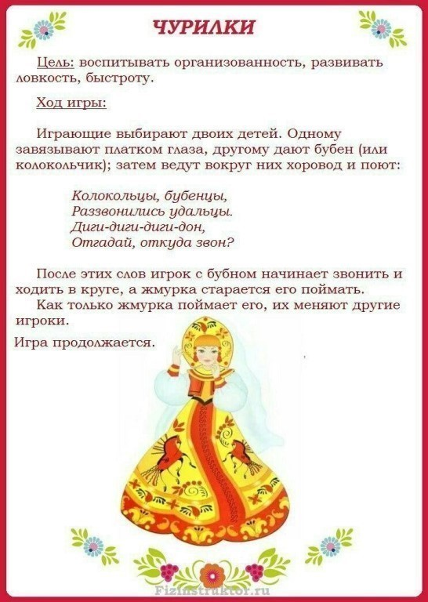](https://ok.ru/dk?cmd=PopLayerPhoto&st.layer.cmd=PopLayerPhotoOuter&st.layer.type=GROUP&st.layer.revNav=off&st.layer.limitedUi=false&st.layer.closeLayers=off&st.layer.sphotoIds=873643025621;873643025365;873643025109;873643024853;873643024597;873643024341;873643024085;873643023829;873643023573;873643023317&st.layer.showNav=on&st.layer.photoAlbumId=52327617003733&st.layer.epm=off&st.layer.photoId=873643023317&st.layer.opl=off&st.layer.navStartPhotoId=873643023317&st.layer.sbd=off&st.cmd=userMain&st._aid=GroupTopicLayer_openPhotoLayer)