**Консультация для родителей "Дети и театр" ✨✨✨✨✨✨✨✨✨✨✨✨**

[](https://ok.ru/dk?cmd=PopLayerPhoto&st.layer.cmd=PopLayerPhotoOuter&st.layer.type=GROUP&st.layer.revNav=off&st.layer.limitedUi=false&st.layer.closeLayers=off&st.layer.sphotoIds=873549504725;873549515221;873549514965;873549514709;873549514197;873549513685&st.layer.showNav=on&st.layer.photoAlbumId=52327617003733&st.layer.epm=off&st.layer.photoId=873549504725&st.layer.opl=off&st.layer.navStartPhotoId=873549504725&st.layer.sbd=off&st.cmd=altGroupForum&st.groupId=52327565361365&st._aid=GroupTopicLayer_openPhotoLayer)

[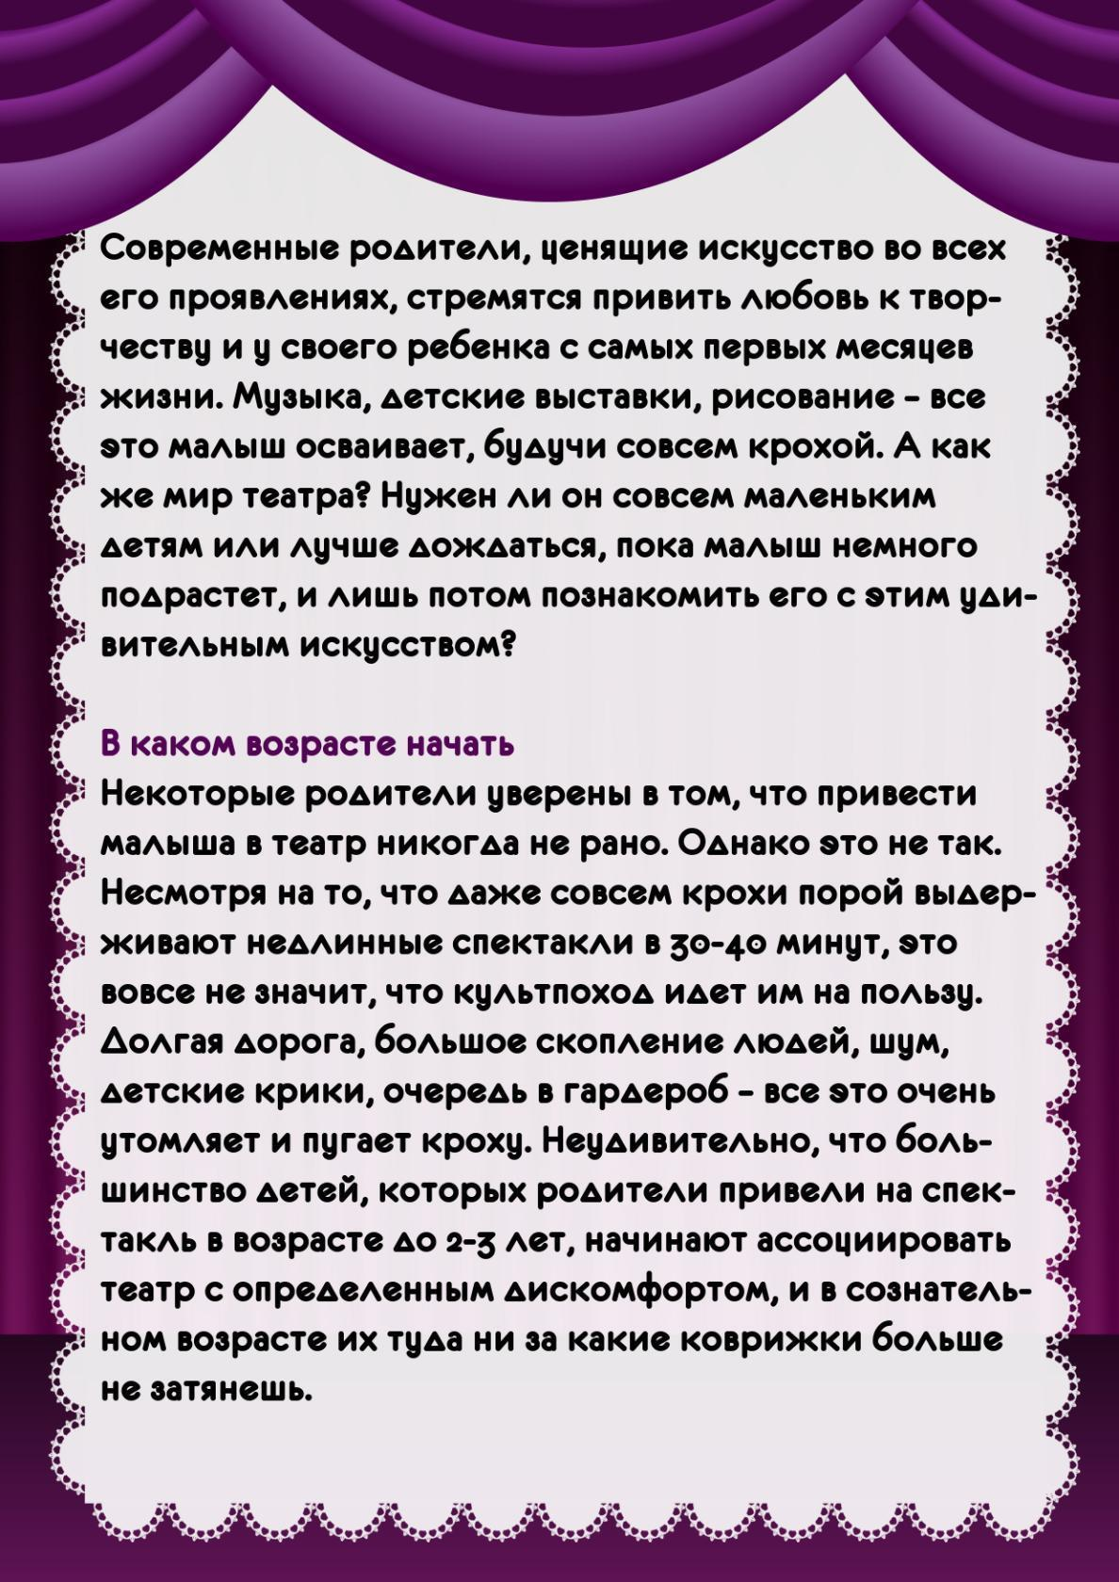](https://ok.ru/dk?cmd=PopLayerPhoto&st.layer.cmd=PopLayerPhotoOuter&st.layer.type=GROUP&st.layer.revNav=off&st.layer.limitedUi=false&st.layer.closeLayers=off&st.layer.sphotoIds=873549504725;873549515221;873549514965;873549514709;873549514197;873549513685&st.layer.showNav=on&st.layer.photoAlbumId=52327617003733&st.layer.epm=off&st.layer.photoId=873549515221&st.layer.opl=off&st.layer.navStartPhotoId=873549515221&st.layer.sbd=off&st.cmd=altGroupForum&st.groupId=52327565361365&st._aid=GroupTopicLayer_openPhotoLayer)

[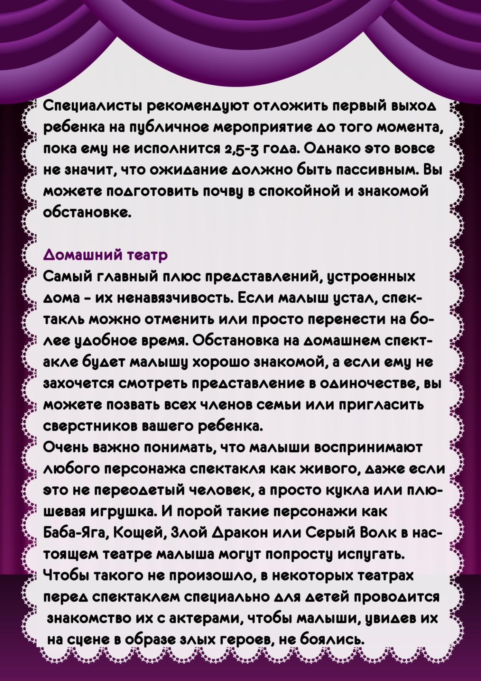](https://ok.ru/dk?cmd=PopLayerPhoto&st.layer.cmd=PopLayerPhotoOuter&st.layer.type=GROUP&st.layer.revNav=off&st.layer.limitedUi=false&st.layer.closeLayers=off&st.layer.sphotoIds=873549504725;873549515221;873549514965;873549514709;873549514197;873549513685&st.layer.showNav=on&st.layer.photoAlbumId=52327617003733&st.layer.epm=off&st.layer.photoId=873549514965&st.layer.opl=off&st.layer.navStartPhotoId=873549514965&st.layer.sbd=off&st.cmd=altGroupForum&st.groupId=52327565361365&st._aid=GroupTopicLayer_openPhotoLayer)

[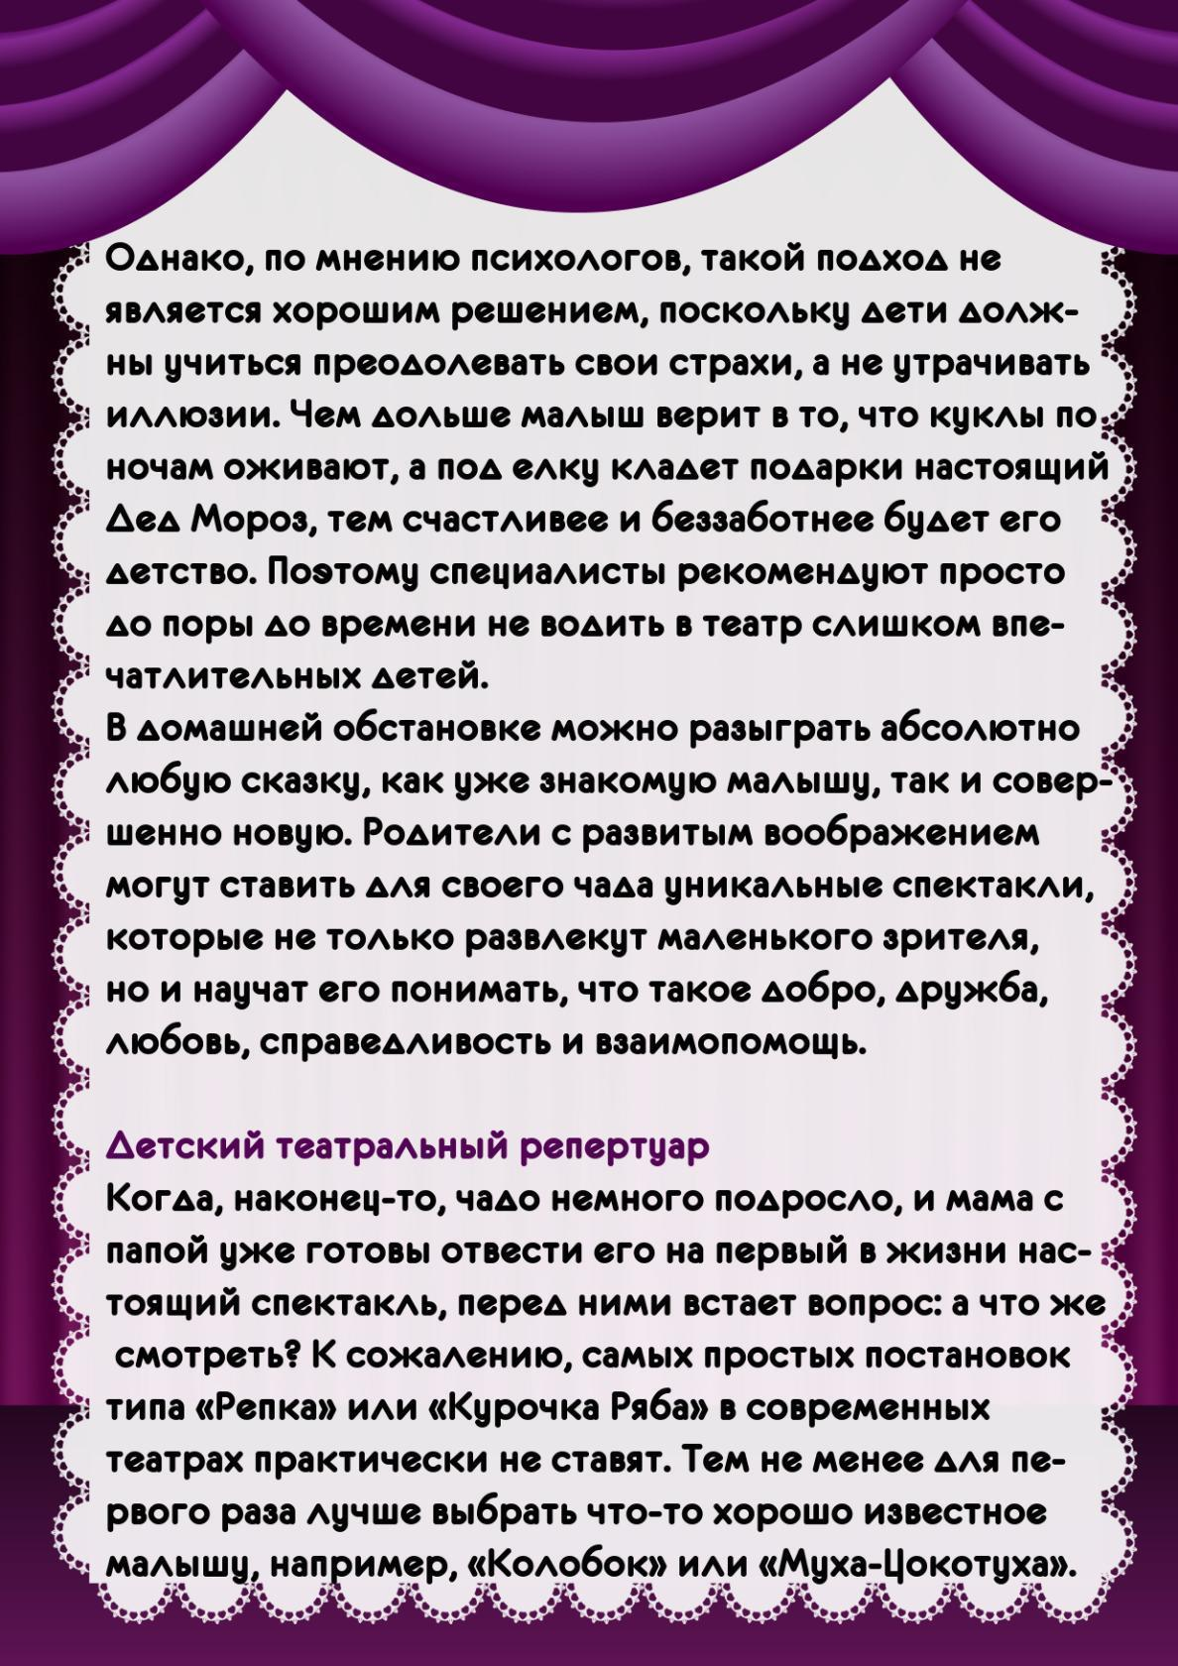](https://ok.ru/dk?cmd=PopLayerPhoto&st.layer.cmd=PopLayerPhotoOuter&st.layer.type=GROUP&st.layer.revNav=off&st.layer.limitedUi=false&st.layer.closeLayers=off&st.layer.sphotoIds=873549504725;873549515221;873549514965;873549514709;873549514197;873549513685&st.layer.showNav=on&st.layer.photoAlbumId=52327617003733&st.layer.epm=off&st.layer.photoId=873549514709&st.layer.opl=off&st.layer.navStartPhotoId=873549514709&st.layer.sbd=off&st.cmd=altGroupForum&st.groupId=52327565361365&st._aid=GroupTopicLayer_openPhotoLayer)

[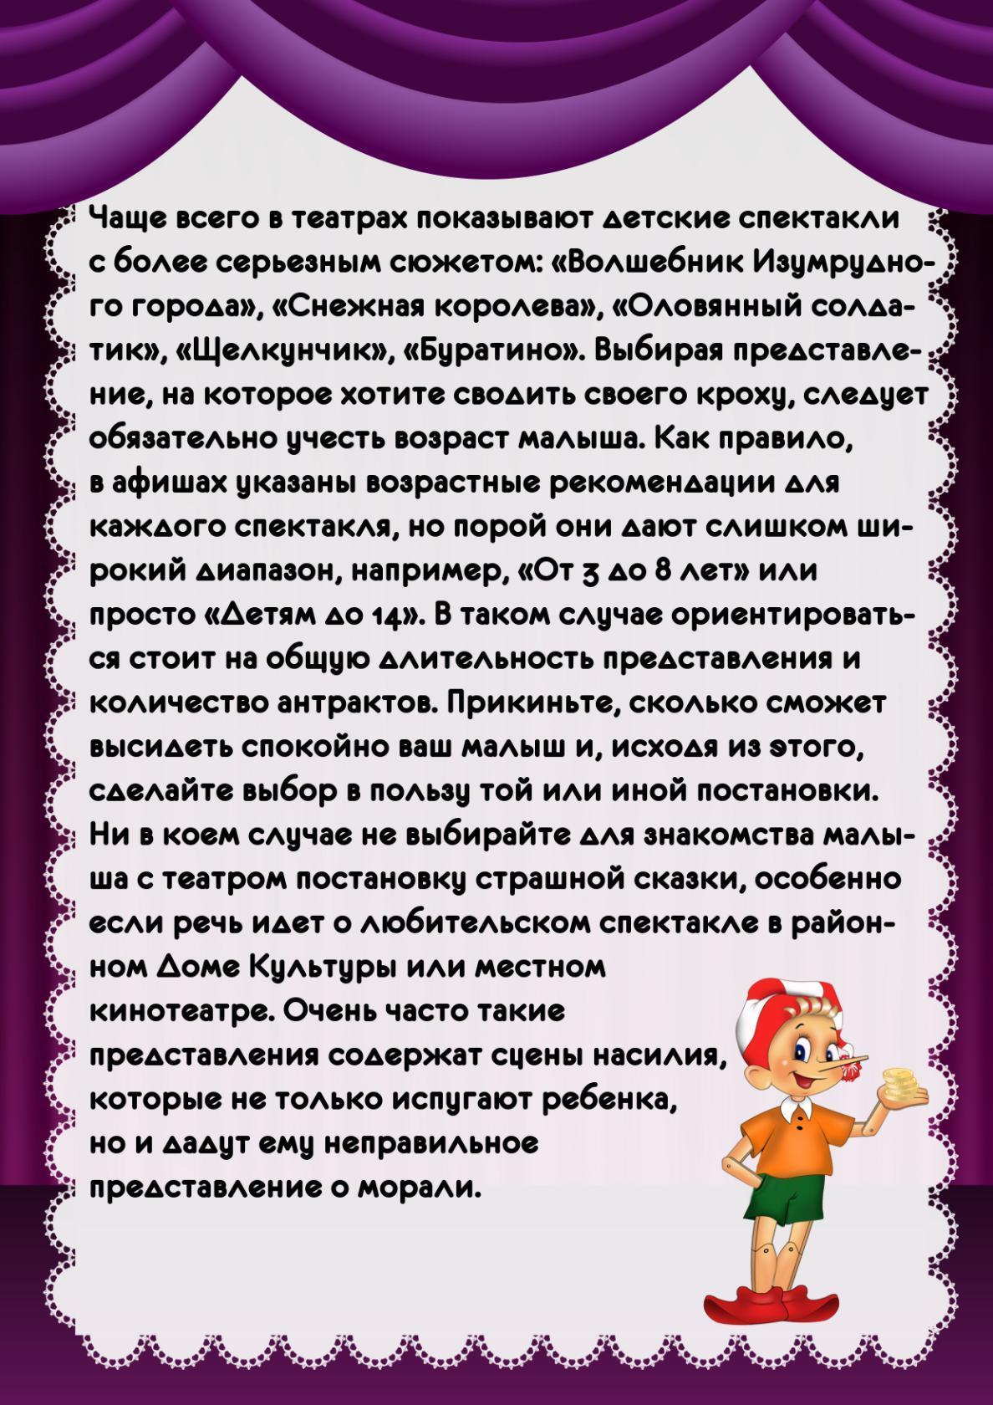](https://ok.ru/dk?cmd=PopLayerPhoto&st.layer.cmd=PopLayerPhotoOuter&st.layer.type=GROUP&st.layer.revNav=off&st.layer.limitedUi=false&st.layer.closeLayers=off&st.layer.sphotoIds=873549504725;873549515221;873549514965;873549514709;873549514197;873549513685&st.layer.showNav=on&st.layer.photoAlbumId=52327617003733&st.layer.epm=off&st.layer.photoId=873549514197&st.layer.opl=off&st.layer.navStartPhotoId=873549514197&st.layer.sbd=off&st.cmd=altGroupForum&st.groupId=52327565361365&st._aid=GroupTopicLayer_openPhotoLayer)

[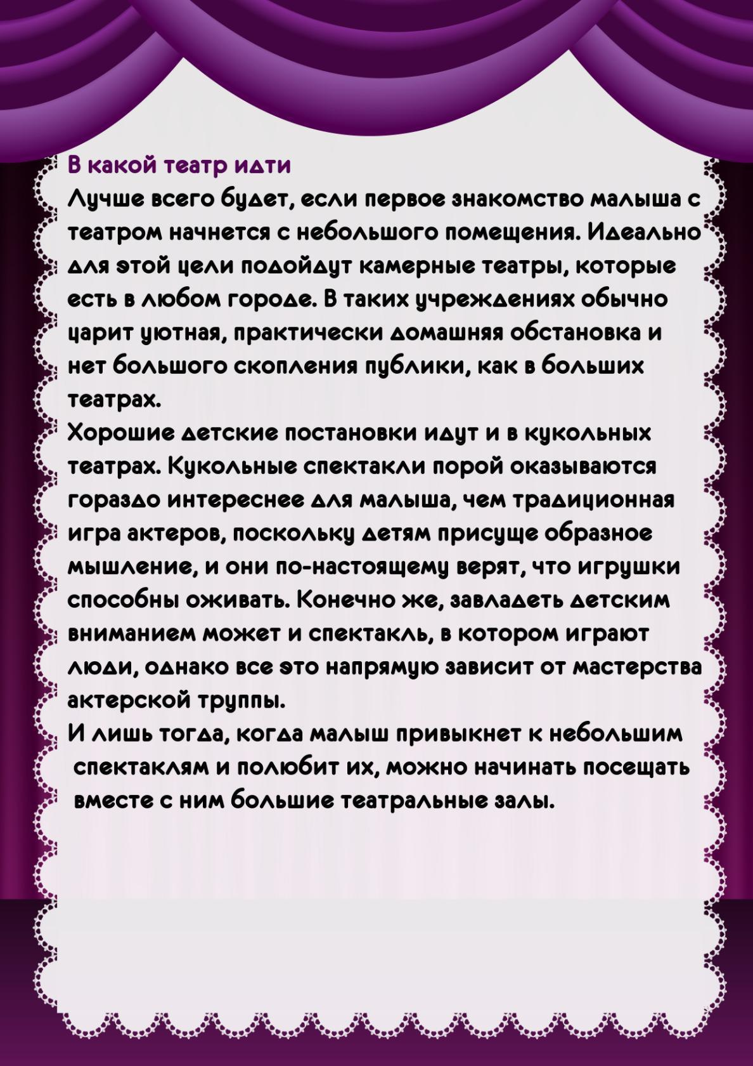](https://ok.ru/dk?cmd=PopLayerPhoto&st.layer.cmd=PopLayerPhotoOuter&st.layer.type=GROUP&st.layer.revNav=off&st.layer.limitedUi=false&st.layer.closeLayers=off&st.layer.sphotoIds=873549504725;873549515221;873549514965;873549514709;873549514197;873549513685&st.layer.showNav=on&st.layer.photoAlbumId=52327617003733&st.layer.epm=off&st.layer.photoId=873549513685&st.layer.opl=off&st.layer.navStartPhotoId=873549513685&st.layer.sbd=off&st.cmd=altGroupForum&st.groupId=52327565361365&st._aid=GroupTopicLayer_openPhotoLayer)