**Музыкально-ритмические игры**

[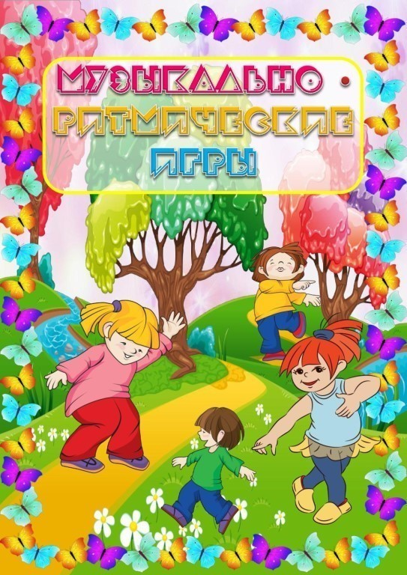](https://ok.ru/dk?cmd=PopLayerPhoto&st.layer.cmd=PopLayerPhotoOuter&st.layer.type=GROUP&st.layer.revNav=off&st.layer.limitedUi=false&st.layer.closeLayers=off&st.layer.sphotoIds=870651970592;870651970336;870651970080;870651969824;870651969568;870651969312;870651969056;870651968800;870651968544;870651968288&st.layer.showNav=on&st.layer.photoAlbumId=57418058629152&st.layer.epm=off&st.layer.photoId=870651970592&st.layer.opl=off&st.layer.navStartPhotoId=870651970592&st.layer.sbd=off&st.cmd=userMain&st._aid=GroupTopicLayer_openPhotoLayer)

[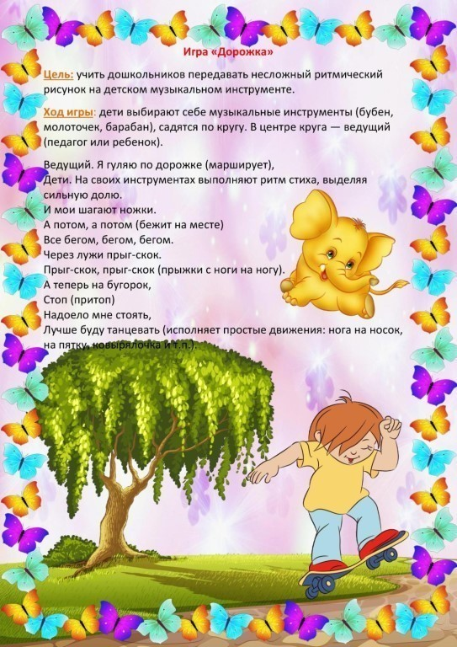](https://ok.ru/dk?cmd=PopLayerPhoto&st.layer.cmd=PopLayerPhotoOuter&st.layer.type=GROUP&st.layer.revNav=off&st.layer.limitedUi=false&st.layer.closeLayers=off&st.layer.sphotoIds=870651970592;870651970336;870651970080;870651969824;870651969568;870651969312;870651969056;870651968800;870651968544;870651968288&st.layer.showNav=on&st.layer.photoAlbumId=57418058629152&st.layer.epm=off&st.layer.photoId=870651970336&st.layer.opl=off&st.layer.navStartPhotoId=870651970336&st.layer.sbd=off&st.cmd=userMain&st._aid=GroupTopicLayer_openPhotoLayer)

[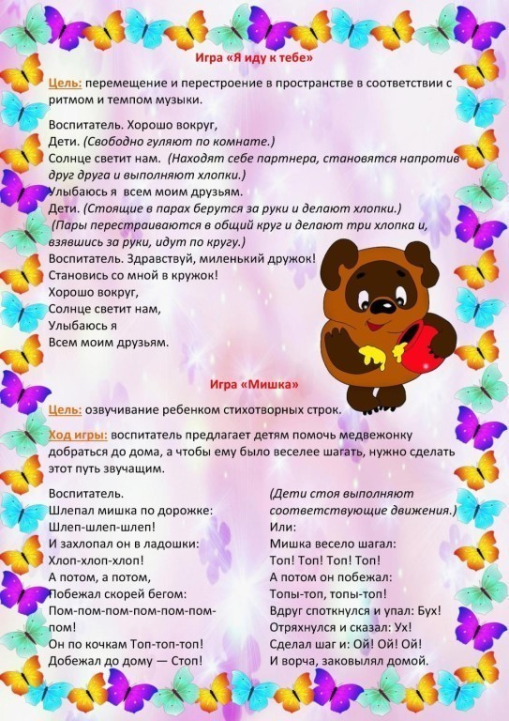](https://ok.ru/dk?cmd=PopLayerPhoto&st.layer.cmd=PopLayerPhotoOuter&st.layer.type=GROUP&st.layer.revNav=off&st.layer.limitedUi=false&st.layer.closeLayers=off&st.layer.sphotoIds=870651970592;870651970336;870651970080;870651969824;870651969568;870651969312;870651969056;870651968800;870651968544;870651968288&st.layer.showNav=on&st.layer.photoAlbumId=57418058629152&st.layer.epm=off&st.layer.photoId=870651970080&st.layer.opl=off&st.layer.navStartPhotoId=870651970080&st.layer.sbd=off&st.cmd=userMain&st._aid=GroupTopicLayer_openPhotoLayer)

[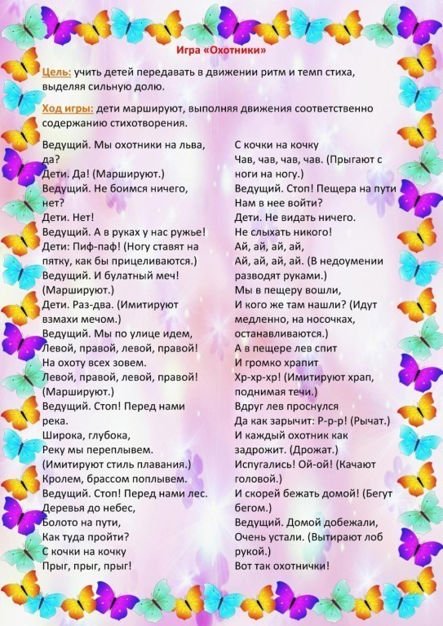](https://ok.ru/dk?cmd=PopLayerPhoto&st.layer.cmd=PopLayerPhotoOuter&st.layer.type=GROUP&st.layer.revNav=off&st.layer.limitedUi=false&st.layer.closeLayers=off&st.layer.sphotoIds=870651970592;870651970336;870651970080;870651969824;870651969568;870651969312;870651969056;870651968800;870651968544;870651968288&st.layer.showNav=on&st.layer.photoAlbumId=57418058629152&st.layer.epm=off&st.layer.photoId=870651969824&st.layer.opl=off&st.layer.navStartPhotoId=870651969824&st.layer.sbd=off&st.cmd=userMain&st._aid=GroupTopicLayer_openPhotoLayer)

[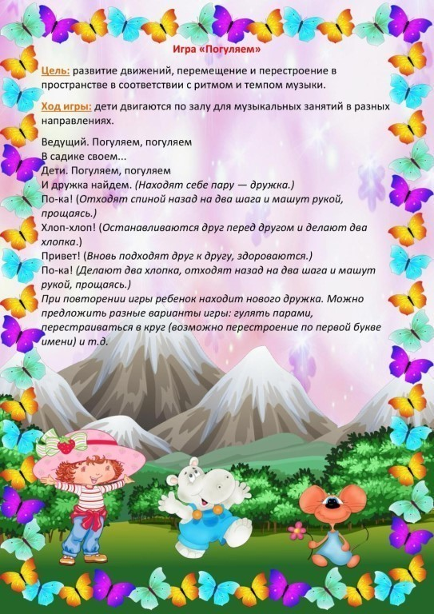](https://ok.ru/dk?cmd=PopLayerPhoto&st.layer.cmd=PopLayerPhotoOuter&st.layer.type=GROUP&st.layer.revNav=off&st.layer.limitedUi=false&st.layer.closeLayers=off&st.layer.sphotoIds=870651970592;870651970336;870651970080;870651969824;870651969568;870651969312;870651969056;870651968800;870651968544;870651968288&st.layer.showNav=on&st.layer.photoAlbumId=57418058629152&st.layer.epm=off&st.layer.photoId=870651969568&st.layer.opl=off&st.layer.navStartPhotoId=870651969568&st.layer.sbd=off&st.cmd=userMain&st._aid=GroupTopicLayer_openPhotoLayer)

[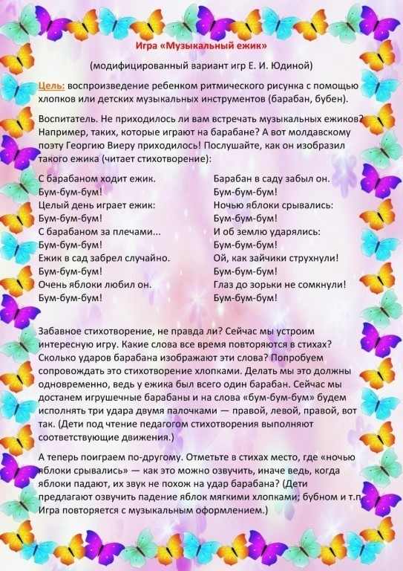](https://ok.ru/dk?cmd=PopLayerPhoto&st.layer.cmd=PopLayerPhotoOuter&st.layer.type=GROUP&st.layer.revNav=off&st.layer.limitedUi=false&st.layer.closeLayers=off&st.layer.sphotoIds=870651970592;870651970336;870651970080;870651969824;870651969568;870651969312;870651969056;870651968800;870651968544;870651968288&st.layer.showNav=on&st.layer.photoAlbumId=57418058629152&st.layer.epm=off&st.layer.photoId=870651969312&st.layer.opl=off&st.layer.navStartPhotoId=870651969312&st.layer.sbd=off&st.cmd=userMain&st._aid=GroupTopicLayer_openPhotoLayer)

[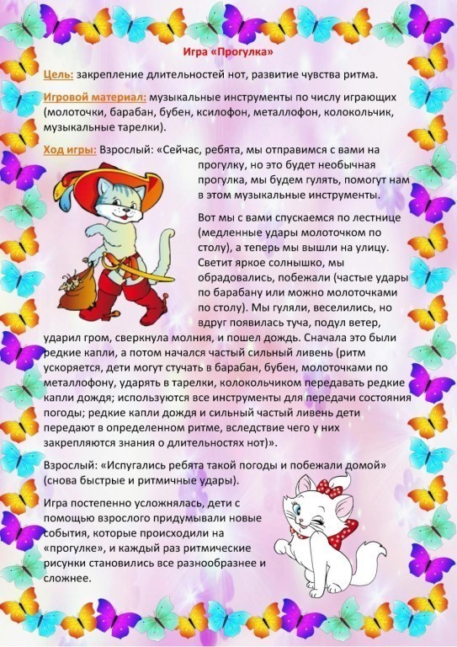](https://ok.ru/dk?cmd=PopLayerPhoto&st.layer.cmd=PopLayerPhotoOuter&st.layer.type=GROUP&st.layer.revNav=off&st.layer.limitedUi=false&st.layer.closeLayers=off&st.layer.sphotoIds=870651970592;870651970336;870651970080;870651969824;870651969568;870651969312;870651969056;870651968800;870651968544;870651968288&st.layer.showNav=on&st.layer.photoAlbumId=57418058629152&st.layer.epm=off&st.layer.photoId=870651969056&st.layer.opl=off&st.layer.navStartPhotoId=870651969056&st.layer.sbd=off&st.cmd=userMain&st._aid=GroupTopicLayer_openPhotoLayer)

[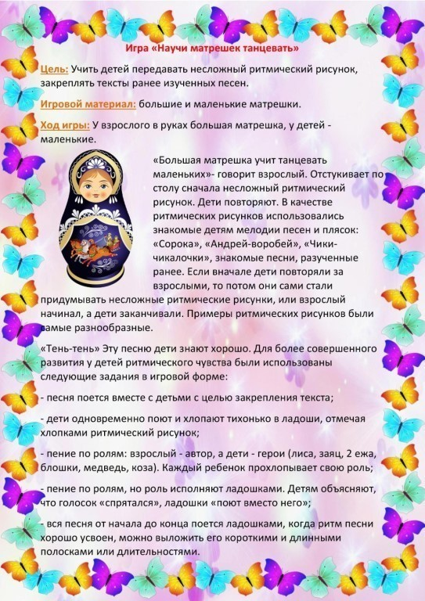](https://ok.ru/dk?cmd=PopLayerPhoto&st.layer.cmd=PopLayerPhotoOuter&st.layer.type=GROUP&st.layer.revNav=off&st.layer.limitedUi=false&st.layer.closeLayers=off&st.layer.sphotoIds=870651970592;870651970336;870651970080;870651969824;870651969568;870651969312;870651969056;870651968800;870651968544;870651968288&st.layer.showNav=on&st.layer.photoAlbumId=57418058629152&st.layer.epm=off&st.layer.photoId=870651968800&st.layer.opl=off&st.layer.navStartPhotoId=870651968800&st.layer.sbd=off&st.cmd=userMain&st._aid=GroupTopicLayer_openPhotoLayer)

[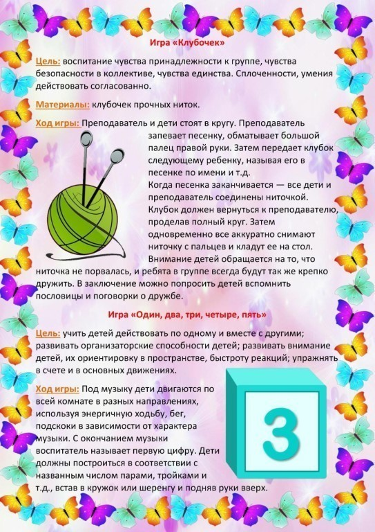](https://ok.ru/dk?cmd=PopLayerPhoto&st.layer.cmd=PopLayerPhotoOuter&st.layer.type=GROUP&st.layer.revNav=off&st.layer.limitedUi=false&st.layer.closeLayers=off&st.layer.sphotoIds=870651970592;870651970336;870651970080;870651969824;870651969568;870651969312;870651969056;870651968800;870651968544;870651968288&st.layer.showNav=on&st.layer.photoAlbumId=57418058629152&st.layer.epm=off&st.layer.photoId=870651968544&st.layer.opl=off&st.layer.navStartPhotoId=870651968544&st.layer.sbd=off&st.cmd=userMain&st._aid=GroupTopicLayer_openPhotoLayer)

[](https://ok.ru/dk?cmd=PopLayerPhoto&st.layer.cmd=PopLayerPhotoOuter&st.layer.type=GROUP&st.layer.revNav=off&st.layer.limitedUi=false&st.layer.closeLayers=off&st.layer.sphotoIds=870651970592;870651970336;870651970080;870651969824;870651969568;870651969312;870651969056;870651968800;870651968544;870651968288&st.layer.showNav=on&st.layer.photoAlbumId=57418058629152&st.layer.epm=off&st.layer.photoId=870651968288&st.layer.opl=off&st.layer.navStartPhotoId=870651968288&st.layer.sbd=off&st.cmd=userMain&st._aid=GroupTopicLayer_openPhotoLayer)